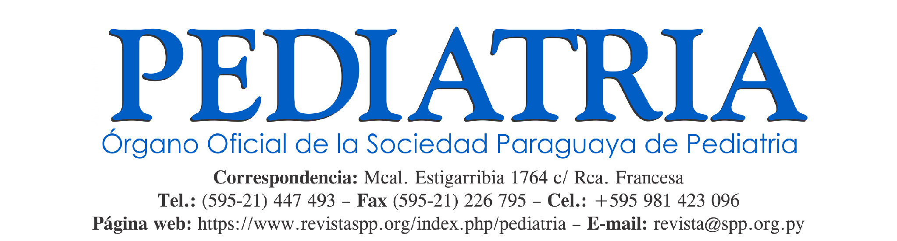

ARTICLE SUBMISSION COMMITMENT LETTER
- The manuscript entitled …………………………………………………..…………… is an original, unpublished manuscript and has not been published or simultaneously submitted for evaluation to any other national or international scientific journal, either in whole or in part, except for its possible deposit on preprint servers.
- The authors undertake not to submit this manuscript to another journal while it is undergoing editorial evaluation by PEDIATRÍA.

AUTHORSHIP STATEMENT
Indicate the contribution of each author according to the CRediT taxonomy (Contributor Roles Taxonomy): 1. Conceptualization, 2. Data curation, 3. Formal analysis, 4. Funding acquisition, 5. Investigation, 6. Methodology, 7. Project administration, 8. Resources, 9. Software, 10. Supervision, 11. Validation, 12. Visualization, 13. Writing – original draft, 14. Writing – review and editing.

No. | First and last name | CONTRIBUTION
1
2
3
4
5
6

AUTHORS’ ORCID IDs

No. | First and last name | ORCID

Affiliations: Indicate the full name of the institution, City, Country (for educational institutions, list the university first, followed by the faculty or institute and the department or academic program, in that order).
No. | First and last name | INSTITUTION

CORRESPONDING AUTHOR

Corresponding author:
Email:
Telephone:
Signature: ______________________________________________________________________

ACKNOWLEDGMENTS
If appropriate, acknowledge individuals or institutions that contributed to the study but were not directly involved in its conception, conduct, methodological framework, revision, or final version.
________________________________________________________________________________________________________________________________________________________________________________________________________________________________________________

EDITORIAL CHECKLIST
All items must be completed. If an item is only partially fulfilled or is not applicable, an explanation must be provided in the Observations section.
Item | Met | Not applicable
1. The manuscript complies with the journal’s publication guidelines and required format.
2. All authors provide their complete institutional affiliation and ORCID identifier and have approved the final version of the manuscript.
3. A funding statement or an explicit statement that no funding was received is included (mandatory).
4. Any potential conflicts of interest are disclosed (mandatory).
5. Ethics Committee approval is attached, including the approval number, when applicable.
6. Individual author contributions are described.
7. Bibliographic references and in-text citations comply with Vancouver style and have been verified.
8. All supplementary documents required by the journal according to the manuscript type are attached (commitment letter, informed consent, etc.).

9. The use or non-use of artificial intelligence tools in the preparation of the manuscript is declared (mandatory).
10. The study database is available upon reasonable request by the journal’s reviewers and editors.

Observations
……………………………………………………………………………………………………………………………………………………………………………………………………

If there are any sources of funding, institutional support, or financial commitments of any kind, they must be specified below.

……………………………………………………………………………………………………………………………………………………………………………………………………

